Unused Workflows

# Overview

It fetches all the workflows which are not being used i.e. which are not mapped on VRA and prepared solely for learning or testing purpose in VRO.

# Goal

It is prepared to systemize the VRO as one can distinguish between used and unused workflow.

# Solution/Logic Design

vcacCafeHost

Fetch IDs(workflowID) of the provisioning workflow of blueprints

For each workflow

If (provisioning workflow != null)

If no

end

end

If yes

Server.getWorfklowWithID

(ProvisioningWorkflowID).name and workflowMap.put(Provisioning Workflow id, workflow name)

Get linked workflow from the items of the provisioning workflow and

workflowMap.put(linked workflow id, linked workflow name)

If (linked workflow != null)

if no

if yes

Call action”getLinkedworkflowArrayfromID”

If linked’s linked workflow among items != null

array.push(name,id)

Fetch all the parent folders of a VRO and get all the workflows exists in these folders

FETCH resource actions

Split the array and

workflowMap.put(linkedLinkedWorkflow name,linkedLinkedWorkflow ID)

For each workflow

If it exist in workflowMap

# if yes if no

Do nothing

unusedWorkflowMap.put(workflow id,workflow details(contains name and path of the workflow))

Iterate the unusedworkflow map and push the name,id and path of the workflow into an array

Write the data to the file through action “writeDataToFile”,attach it with the mail and send the mail through “Send mail”

end

# Unused Workflow Properties

* Workflow Name – Name of the workflow which are not being used
* Workflow Id – ID of the corresponding workflow as there could be workflows with the same name so id would be the unique parameter which will tell whether a workflow is being used or not.
* Path of the workflow – location of the workflow at VRO.

Dependencies

# Related Actions

* WriteDataToTheFile – It writes the requested data to the file.
* ValidateEmail – It validates the email address.
* GetLinkedWorkflowArrayWithId – it is getting the linked workflow of a workflow with the help of the workflow id.
* GetParentFolders – This action let one choose the number of folders in which one has to get unused workflows.

# Related Workflows

* Send Mail – It attaches the file to the mail and send it to the specified requester.

# Related Configuration Elements

* fromName – Sender’s Name
* fromAddress – Sender’s Address
* vcaccafeHost – It is the host through which VRO connect with VRA to fetch the required data.
* smtpHost – with which one will be able to connect to the server to send the mail.
* CcAddress – it includes other member’s mail address to whom requester wants to send the mail.
* smtpPort - with which one will be able to connect to the server to send the mail.

# Attributes

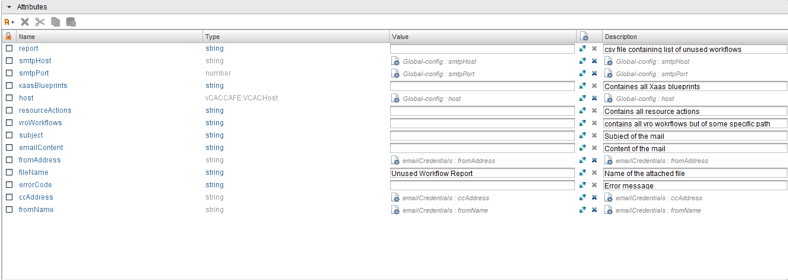

# Inputs

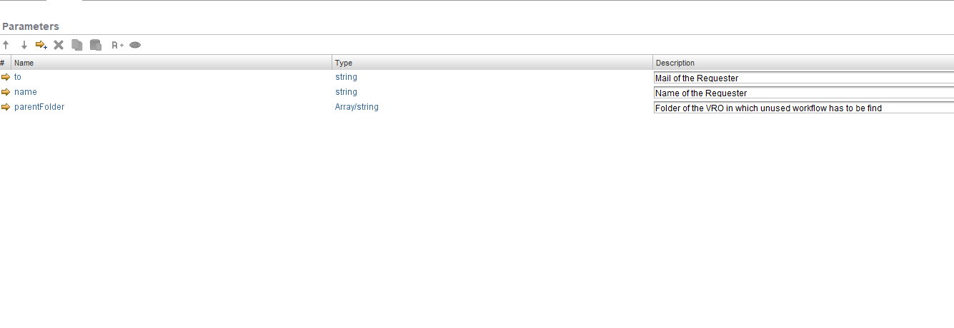

# Future Scope

The workflow can to extended to:

* to fetch more linked workflows to get more and more unused workflows.